

SCE Training Curriculum

Siemens Automation Cooperates with Education | 05/2017

Beschreibung: SIE_Logo_Layer_Petrol_RGB_A4_56mmTIA Portal Module 032-300

IEC Timers and IEC Counters  
Multi-instances for SIMATIC S7-1500

**Matching SCE trainer packages for these training curriculums**

SIMATIC Controllers

* **SIMATIC ET 200SP Open Controller CPU 1515SP PC F and HMI RT SW**Order no.: 6ES7677-2FA41-4AB1
* **SIMATIC ET 200SP Distributed Controller CPU 1512SP F-1 PN Safety**

Order no.: 6ES7512-1SK00-4AB2

* **SIMATIC CPU 1516F PN/DP Safety**

Order no.: 6ES7516-3FN00-4AB2

* **SIMATIC S7 CPU 1516-3 PN/DP**Order no.: 6ES7516-3AN00-4AB3
* **SIMATIC CPU 1512C PN with Software and PM 1507**Order no.: 6ES7512-1CK00-4AB1
* **SIMATIC CPU 1512C PN with Software, PM 1507 and CP 1542-5 (PROFIBUS)**Order no.: 6ES7512-1CK00-4AB2
* **SIMATIC CPU 1512C PN with Software**Order no.: 6ES7512-1CK00-4AB6
* **SIMATIC CPU 1512C PN with Software and CP 1542-5 (PROFIBUS)**Order no.: 6ES7512-1CK00-4AB7

**SIMATIC STEP 7 Software for Training**

* **SIMATIC STEP 7 Professional V14 SP1 - Single license**Order no.: 6ES7822-1AA04-4YA5
* **SIMATIC STEP 7 Professional V14 SP1- Classroom license (up to 6 users)**Order no.: 6ES7822-1BA04-4YA5
* **SIMATIC STEP 7 Professional V14 SP1 - Upgrade license (up to 6 users)**Order no.: 6ES7822-1AA04-4YE5
* **SIMATIC STEP 7 Professional V14 SP1 - Student license (up to 20 users)**Order no.: 6ES7822-1AC04-4YA5

Note that these trainer packages are replaced with successor packages when necessary.

An overview of the currently available SCE packages is provided at: [siemens.com/sce/tp](http://www.siemens.com/tp)

**Continued training**

For regional Siemens SCE continued training, get in touch with your regional SCE contact [siemens.com/sce/contact](http://www.siemens.com/contact)

**Additional information regarding SCE**

[siemens.com/sce](http://www.siemens.com/sce)

**Information regarding use**

The SCE training curriculum for the integrated automation solution Totally Integrated Automation (TIA) was prepared for the program "Siemens Automation Cooperates with Education (SCE)" specifically for training purposes for public educational and R&D institutions. Siemens AG does not guarantee the contents.

This document is to be used only for initial training on Siemens products/systems. This means it can be copied in whole or part and given to those being trained for use within the scope of their training. Circulation or copying this training curriculum and sharing its content is permitted within public training and advanced training facilities for training purposes.

Exceptions require written consent from the Siemens AG contact: Roland Scheuerer roland.scheuerer@siemens.com.

Offenders will be held liable. All rights including translation are reserved, particularly if a patent is granted or a utility model or design is registered.

Use for industrial customer courses is expressly prohibited. We do not consent to commercial use of the training curriculums.

We wish to thank the TU Dresden, particularly Prof. Dr.-Ing. Leon Urbas, Michael Dziallas Engineering Corporation and all other involved persons for their support during the preparation of this training curriculum.

Table of contents

[1 Goal 5](#_Toc486001351)

[2 Prerequisite 5](#_Toc486001352)

[3 Required hardware and software 6](#_Toc486001353)

[4 Theory 7](#_Toc486001354)

[4.1 Instances and multi-instances in SIMATIC S7-1500 7](#_Toc486001355)

[4.1.1 Instance data blocks/single instances 8](#_Toc486001356)

[4.1.2 Multi-instances 9](#_Toc486001357)

[5 Task 11](#_Toc486001358)

[6 Planning 11](#_Toc486001359)

[6.1 Automatic mode - Conveyor motor with time function 11](#_Toc486001360)

[7 Structured step-by-step instructions 12](#_Toc486001361)

[7.1 Retrieve an existing project 12](#_Toc486001362)

[7.2 Addition of an IEC timer TP to function block FB1 "MOTOR\_AUTO" 14](#_Toc486001363)

[7.3 Update the block call in the organization block 20](#_Toc486001364)

[7.4 Save and compile the program 21](#_Toc486001365)

[7.5 Download the program 22](#_Toc486001366)

[7.6 Monitor program blocks 23](#_Toc486001367)

[7.7 Archive the project 25](#_Toc486001368)

[8 Checklist 26](#_Toc486001369)

[9 Exercise 27](#_Toc486001370)

[9.1 Task – Exercise 27](#_Toc486001371)

[9.2 Planning 27](#_Toc486001372)

[9.3 Checklist – Exercise 28](#_Toc486001373)

[10 Additional information 29](#_Toc486001374)

IEC Timers and IEC Counters Multi-instances for SIMATIC S7-1500

# Goal

In this chapter, you will become acquainted with the use of single instances and multi-instances for programming of the SIMATIC S7-1500 with the TIA Portal programming tool.

The module explains the various types of instance data blocks and shows step-by-step how to add IEC timers and IEC counters to a program block.

The SIMATIC S7 controllers listed in Chapter 3 can be used.

# Prerequisite

This chapter builds on the FB programming with the SIMATIC S7 CPU1516F-3 PN/DP. You can use the following project for this chapter, for example: 032‑200\_FBProgramming\_R1503.zap13

# Required hardware and software

**1** Engineering station: requirements include hardware and operating system   
(for additional information, see Readme on the TIA Portal Installation DVDs)

**2** SIMATIC STEP 7 Professional software in TIA Portal – as of V13

**3** SIMATIC S7-1500/S7-1200/S7-300 controller, e.g. CPU 1516F-3 PN/DP –   
Firmware as of V1.6 with memory card and 16DI/16DO and 2AI/1AO  
Note: The digital inputs should be fed out to a control panel.

**4** Ethernet connection between engineering station and controller

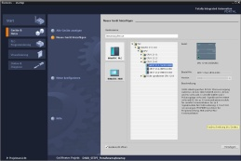

**2** SIMATIC STEP 7 Professional (TIA Portal) as of V13



**1** Engineering station

**4** Ethernet connection



Control panel

**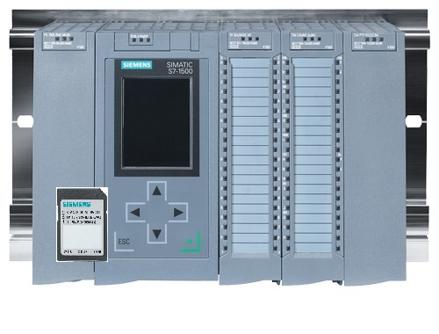**

**3** SIMATIC S7-1500 controller

# Theory

## Instances and multi-instances in SIMATIC S7-1500

The call of a function block is referred to as an **instance**. An **instance** is assigned to every call of a function block and serves as a data memory. It stores the actual parameters and the static data of the function block.

The tags declared in the function block determine the structure of the instance data block.

**Use of single instances and multi-instances**

You can assign instances as follows:

Call as a **single instance**:

- A separate instance data block for each instance of a function block

Call as a **multi-instance**:

- One instance data block for several instances of one or more function blocks

### Instance data blocks/single instances

The call of a function block that is assigned its own [instance data block](mk:@MSITStore:C:\Program%20Files\Siemens\Automation\Portal%20V10\Help\de-DE\ProgPLC2MdeDE.chm::/10866491403/10866751755.htm##) is called a **single instance**.

If the function block was created according to the rules for library-compatible standard blocks, it can also be called multiple times.

However, you must assign another instance data block for each call as a single instance.

**Example of single instances:**

The following figure shows the control of two motors using one function block FB10 and two different data blocks:

The different data for the individual motors, such as speed, acceleration time and total operating time, are saved in the instance data blocks DB10 and DB11.

OB1

Call of FC1

DB11

Instance DB for second call with data for Motor 2

DB10

Instance DB for second call with data for Motor 1

FC1

Call of FB10 with instance DB10

for control of Motor 1

Call of FB10 with instance DB11

for control of Motor 2

FB10

Standard block with motor program

FB10

Standard block with motor program

**Note:** Some commands, such as timers and counters, react like function blocks. When these are called, they also require an assigned memory area, e.g. in the form of an instance data block.

### Multi-instances

You may want to limit the number of data blocks used for instances or this may be necessary due to lack of memory in the utilized CPU.

If other function blocks, timers, counters, etc. that already exist will be called in a function block in your user program, you can call these other function blocks without separate (i.e., additional) instance DBs.

Simply select ‘**Multi-instance**’ for the call options:

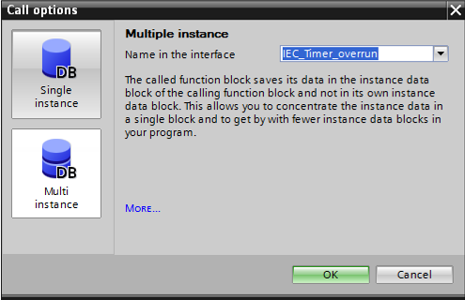

**Notes:** Multi-instances enable a called function block to store its data in the instance data block of the calling function block.

In this case, the calling block must always be a function block.

This allows you to concentrate the instance data in one instance data block and thus make better use of the number of DBs available.

Incidentally, this is always required when the calling block is to remain available for reuse as a standard block.

**Example of multi-instances:**

The following figure shows two calls of an IEC\_Timer of type TP (pulse) within a function block.

The different data for the two counters is stored as different **multi-instances** in the instance data block DB1 of the calling function block FB1.

DB1

(Instance DB for FB1)

Static tag

#Timer1 IEC\_Timer

#Timer2 IEC\_Timer as multi-instance

OB1

Call FB1 with instance DB1

FB1

Call IEC\_Timer as multi-instance #Timer1

Call IEC\_Timer as multi-instance #Timer2

#Timer2  
of type IEC\_Timer

#Timer1  
of type IEC\_Timer

# Task

In this chapter, an IEC timer will be added to the function block from chapter "SCE\_EN\_032-200 FB Programming".

# Planning

The IEC timer is programmed as an addition to the MOTOR\_AUTO [FB1] function block from the "032-200\_FBProgramming.zap13" project. This project must be retrieved in order to add the IEC timer TP (latching pulse). A multi-instance will be created as a memory for the timer.

## Automatic mode - Conveyor motor with time function

The Memory\_automatic\_start\_stop is latched with Start but only if the reset conditions are not present.

The Memory\_automatic\_start\_stop is reset if Stop is present or safety shutoff is active or automatic mode is not activated (manual mode).

The Conveyor\_motor\_automatic\_mode output is activated when Memory\_automatic\_start\_stop is set, the enable conditions are met and Memory\_conveyor\_start\_stop is set.

To save energy, the conveyor should only run when a part is present.

For this reason, the Memory\_conveyor\_start\_stop is set when Sensor\_chute\_occupied signals a part and reset when Sensor\_end\_of\_conveyor produces a negative edge or safety shutoff is active or automatic mode is not activated (manual mode).

**Addition of time function:**

Because the Sensor\_end\_of\_conveyor is not able to be mounted directly at the end of the conveyor, the Sensor\_end\_of\_conveyor signal must be stretched.

To achieve this, a latching pulse will be inserted between Sensor\_end\_of\_conveyor and the negative edge detection.

# Structured step-by-step instructions

You can find instructions on how to carry out planning below. If you already have a good understanding of everything, it will be sufficient to focus on the numbered steps. Otherwise, simply follow the detailed steps in the instructions.

## Retrieve an existing project

* Before we can expand the "MOTOR\_AUTO [FB1]" function block, we must retrieve the "032-200\_FBProgramming.zap13" project from chapter "SCE\_EN\_032-200 FBProgramming". To retrieve an existing project that has been archived, you must select the relevant archive with → Project → Retrieve in the project view. Confirm your selection with Open. (→ Project → Retrieve → Select a .zap archive → Open)

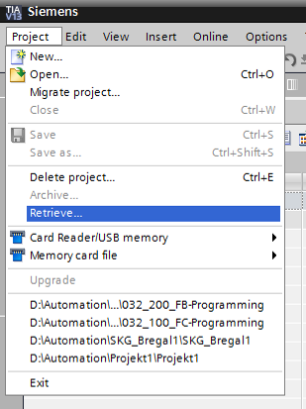

* The next step is to select the target directory where the retrieved project will be stored. Confirm your selection with "OK". (→ Target directory → OK)

Save the opened project under the name 032-300\_IEC\_Timers\_Counters.   
→ Project → Save as ... → 032-300-IEC\_Timers\_Counters → Save)

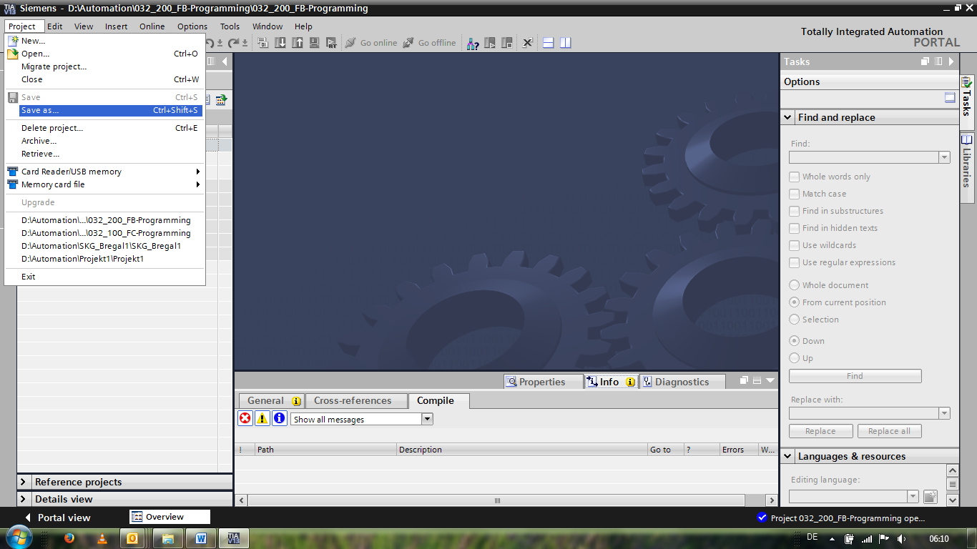

## Addition of an IEC timer TP to function block FB1 "MOTOR\_AUTO"

* First, open the "MOTOR\_AUTO [FB1]" function block with a double-click.

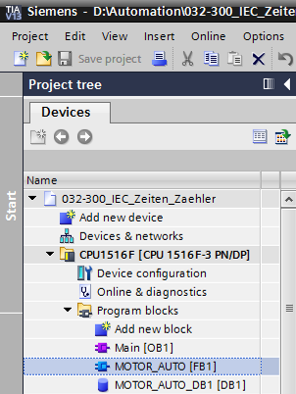

* Insert another network at the beginning of the "MOTOR\_AUTO [FB1]" function block by selecting the → "block title" and then clicking the →  icon for "Insert network".

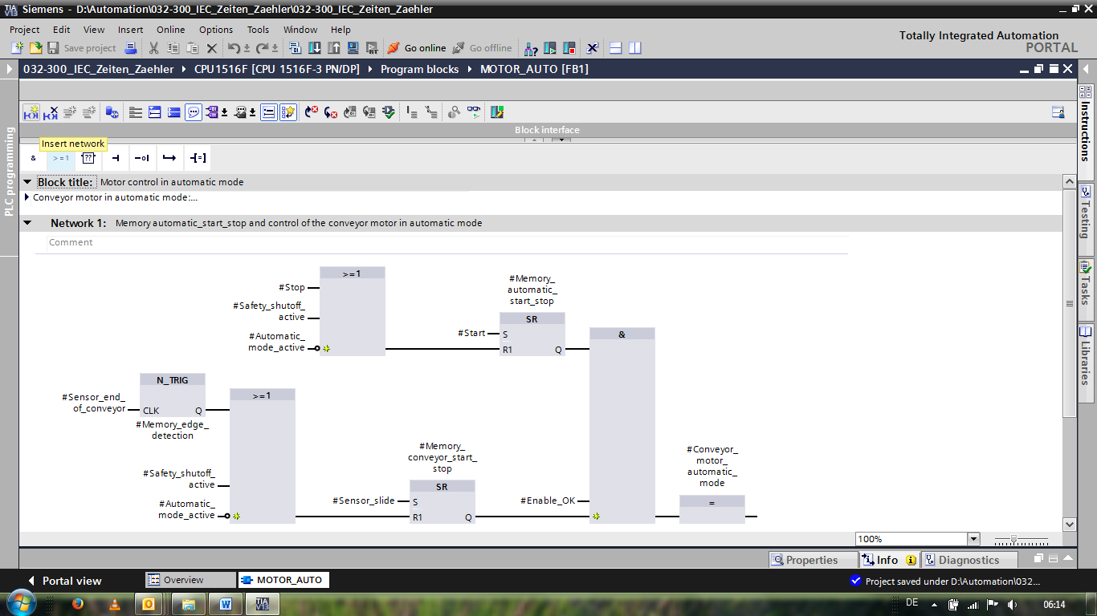

* Add helpful information to the block comment and the network title of "Network 1:".

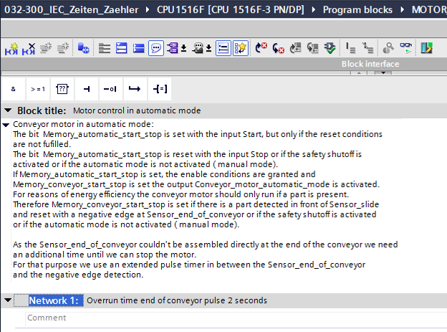

* On the right side of your programming window, you will see the timer functions in the list of instructions. Under → Basic instructions → Timer operations, find function  (Generate pulse) and use a drag-and-drop operation to move it to Network 1 (green line appears, mouse pointer with + symbol).

(→ Instructions → Basic instructions → Timer operations →  )

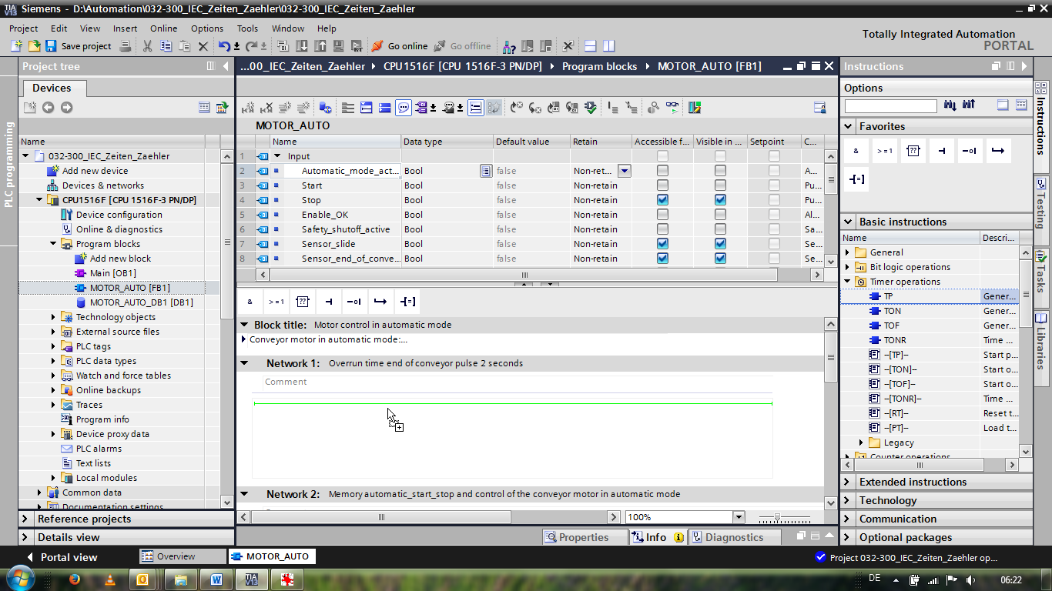

* The timer function requires a memory. Here, this memory is made available within the instance data block by the function block without the creation of a new instance data block. Select the →"Multi-instance" option for this. Enter a name for the multi-instance and confirm with → "OK". (→ Multi-instance → IEC\_Timer\_overrun → OK)



* As a result, a tag structure of "Static" type suitable for TP Timer will be created in the interface description.

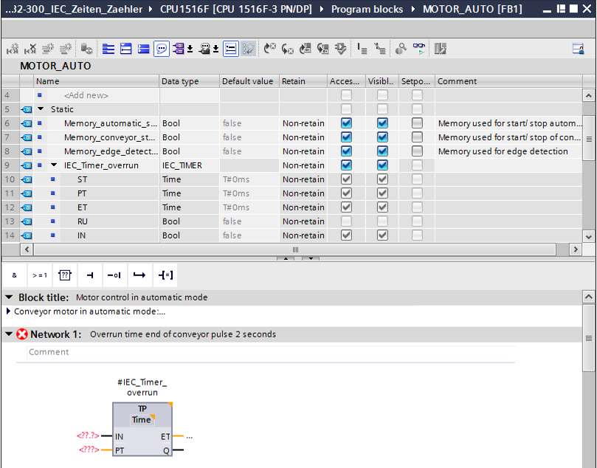

**Note:** A multi-instance can only be used for programming within a function block because static tags are only available there.

* Use drag-and-drop to move input parameter #Sensor\_end\_of\_conveyor to <??.?> in front of parameter "IN" of TP Timer so that this will be started at a positive edge at input #Sensor\_end\_of\_conveyor. The best way to select a parameter in the interface description is by "grabbing" it at the blue symbol.  (→  Sensor\_end\_of\_conveyor)

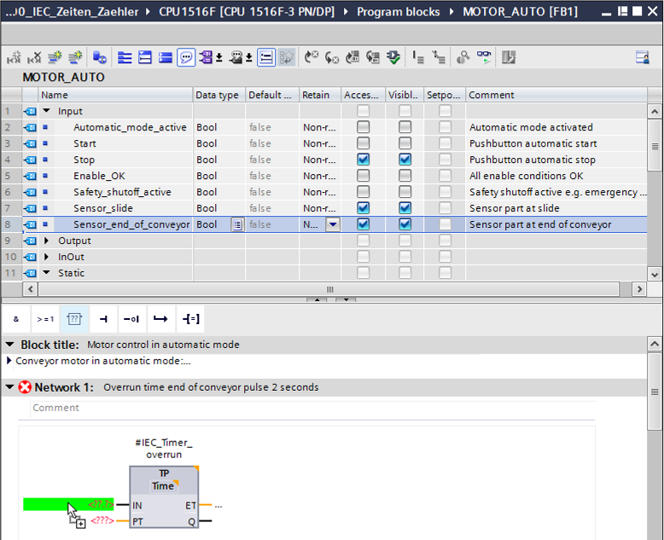

* Enter the required pulse duration of 2 seconds in front of parameter "PT" (→ 2s )

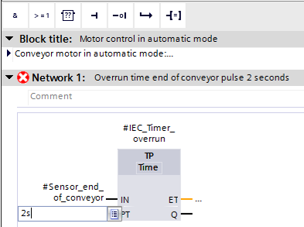

* The entry of 2s is converted automatically to the IEC-Time format suitable for the IEC timer and is shown as constant "T#2s".

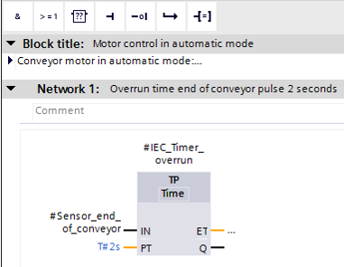

* Now move output "Q" from tag structure "IEC\_Timer\_overrun" onto input "CLK" of negative edge "N\_TRIG" in Network 2. This will replace the #Sensor\_end\_of\_conveyor input tag previously entered there and the conveyor will be stopped by a negative edge of the IEC\_Timer\_overrun pulse.

(→ Network 2 → IEC\_Timer\_overrun→ Q → #Sensor\_end\_of\_conveyor)

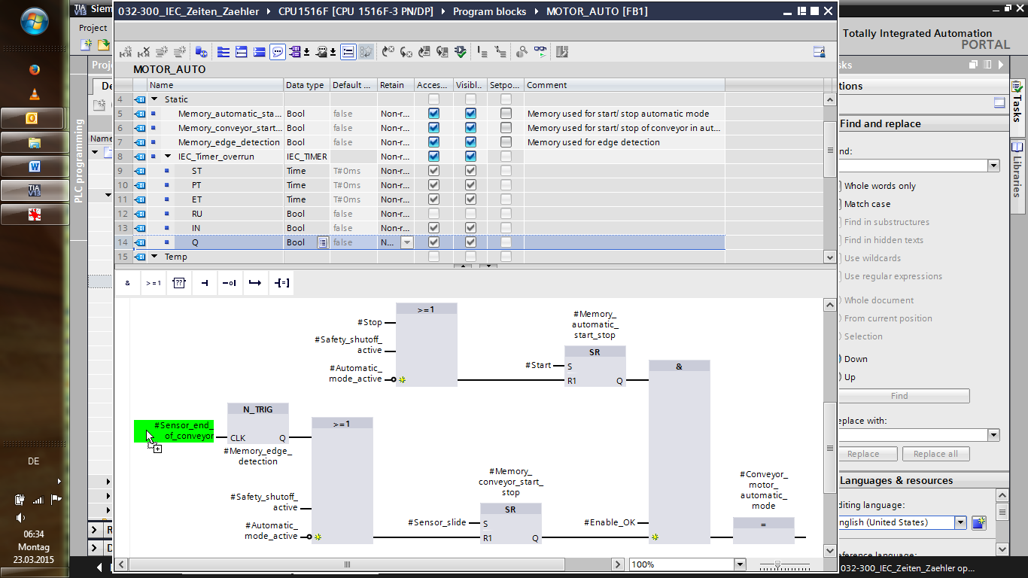

* Do not forget to click 27_save. The finished function block "MOTOR\_AUTO" [FB1] with the timer is shown in FBD below.

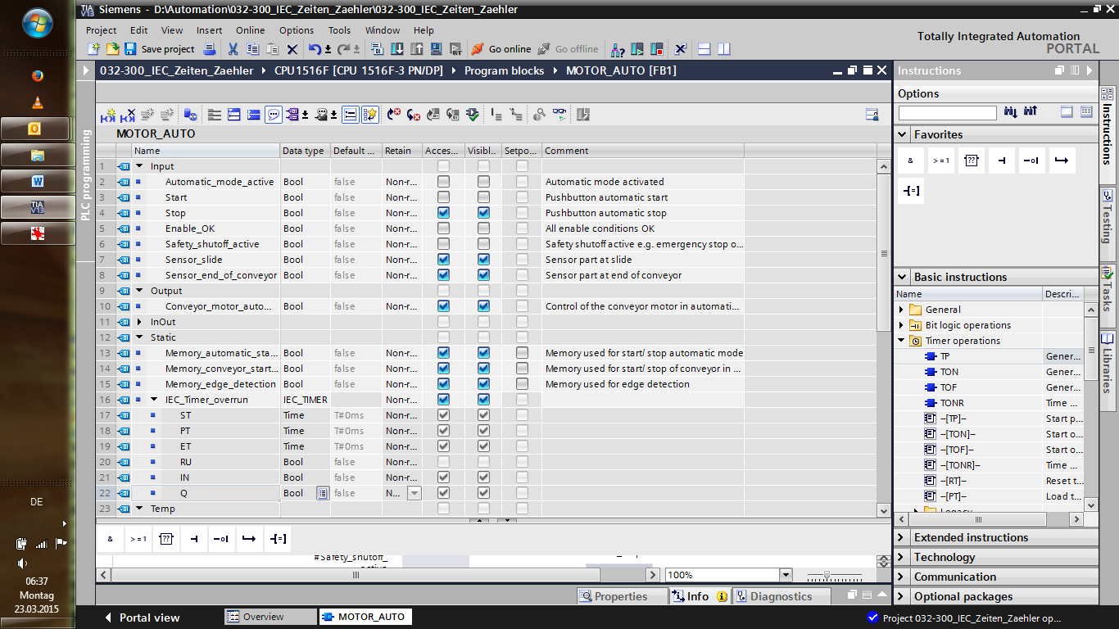

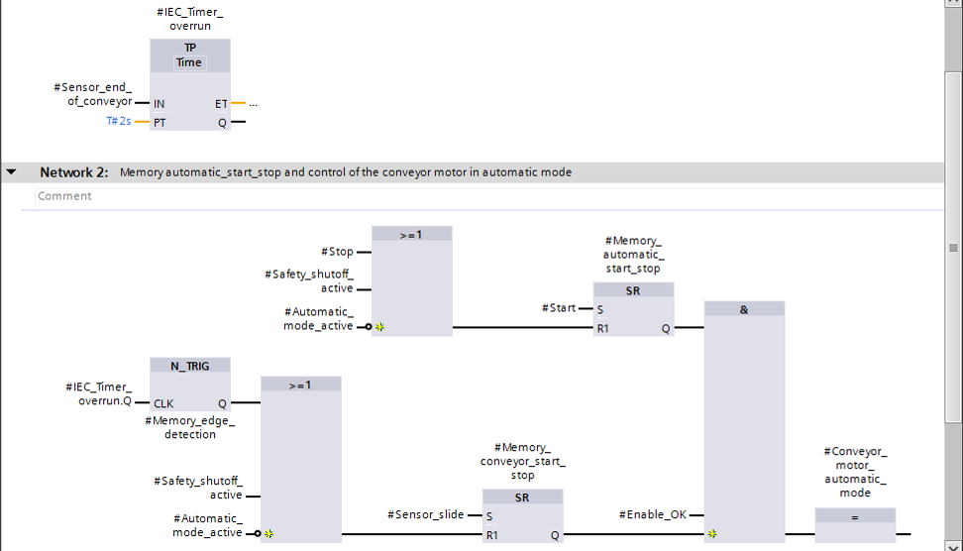

## Update the block call in the organization block

* Open the "Main [OB1]" organization block with a double-click.

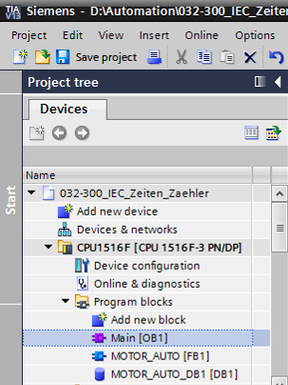

* In Network 1 of the "Main [OB1" organization block, instance data block "MOTOR\_AUTO\_DB1" for the "MOTOR\_AUTO [FB1]" function block appears incorrect, because the additional memory for the TP Timer has not yet been added there. Click the → "" icon for "Update inconsistent block calls". This will add the "MOTOR\_AUTO\_DB1" instance data block correctly again. (→  )

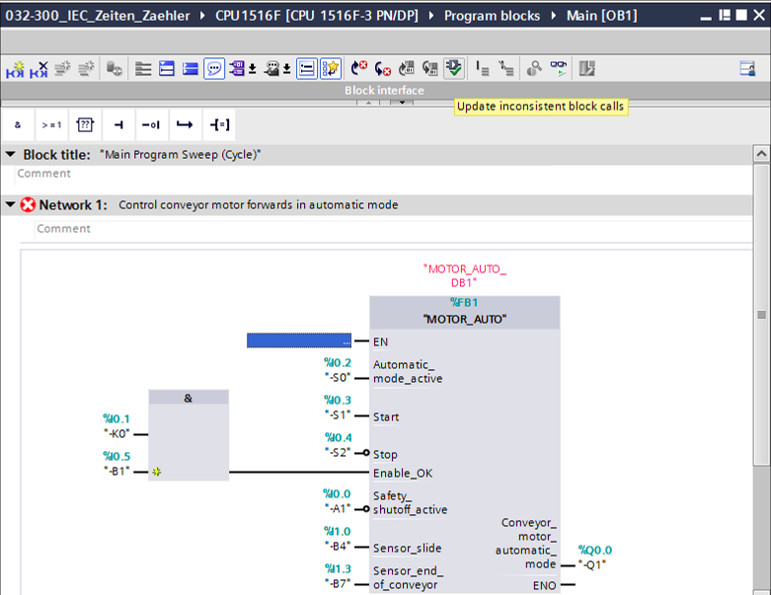

## Save and compile the program

* To save your project, select the 27_save button in the menu. To compile all blocks, click the "Program blocks" folder and select the D:\00_DATA\SIEMENS\Unterlagen\08_Ausbildungsunterlage_TIA-Portal_R1502_dt\032-100 FC-Programmierung\pics\052.jpg icon for compiling in the menu   
  (→ 27_save → Program blocks → D:\00_DATA\SIEMENS\Unterlagen\08_Ausbildungsunterlage_TIA-Portal_R1502_dt\032-100 FC-Programmierung\pics\052.jpg).

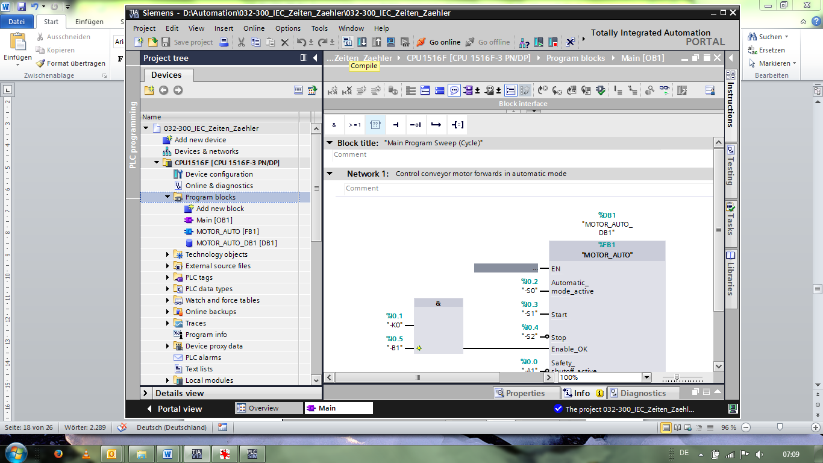

* The "Info", "Compile" area shows which blocks were successfully compiled.

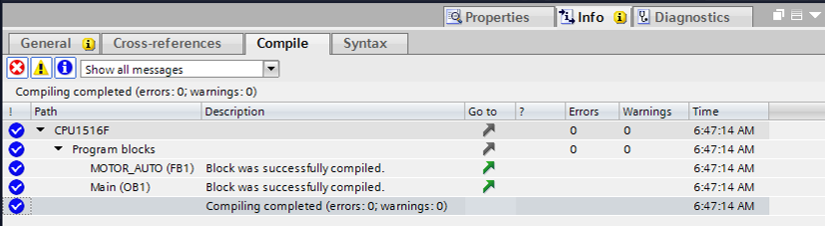

## Download the program

* After successful compilation, the complete controller with the created program including the hardware configuration, as previously described in the modules, can be downloaded. (→ )

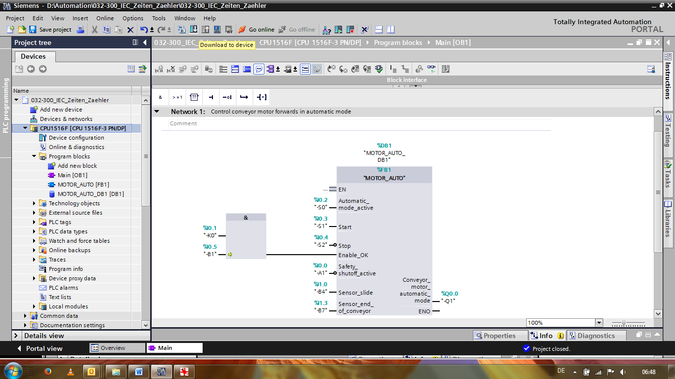

## Monitor program blocks

* The desired block must be open for monitoring the downloaded program. The monitoring can now be activated/deactivated by clicking the D:\00_DATA\SIEMENS\Unterlagen\08_Ausbildungsunterlage_TIA-Portal_R1502_dt\032-100 FC-Programmierung\pics\055b.jpg icon. (→ Main [OB1] → D:\00_DATA\SIEMENS\Unterlagen\08_Ausbildungsunterlage_TIA-Portal_R1502_dt\032-100 FC-Programmierung\pics\055b.jpg)

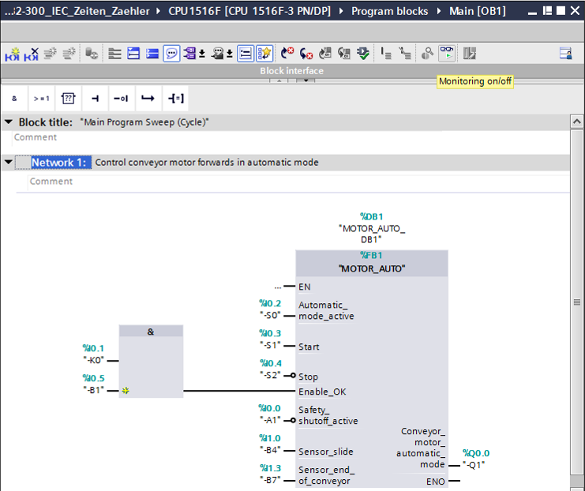

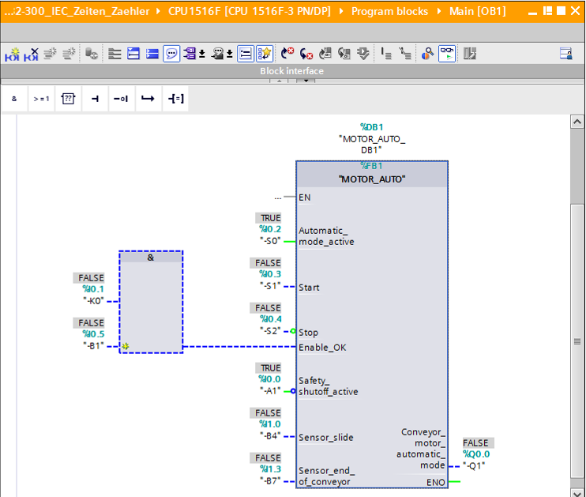

***Note:*** *The monitoring here is signal-related and controller-dependent. The signal states at the terminals are indicated with TRUE or FALSE.*

* The "MOTOR\_AUTO" [FB1] function block called in the "Main [OB1]" organization block can be selected directly for "Open and monitor" after right-clicking, thereby allowing the program code in the function block with the TP Timer to be monitored.   
  (→ "MOTOR\_AUTO" [FB1] → Open and monitor)

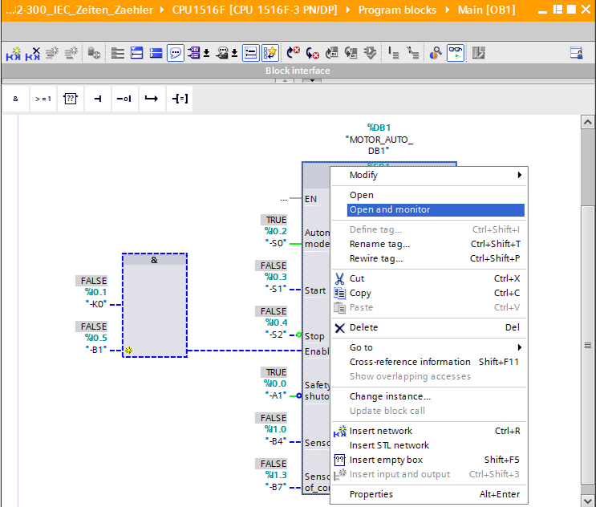

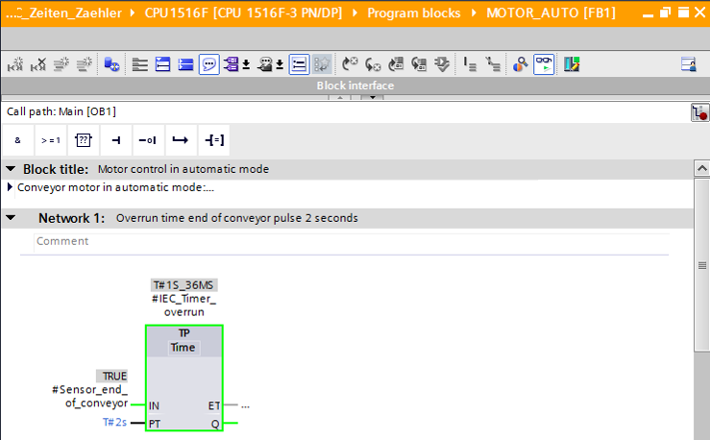

***Note:*** *The monitoring here is function-related and controller-independent. The actuation of sensors and the station status are shown here with TRUE or FALSE.*

## Archive the project

* As the final step, we want to archive the complete project. Select the → "Archive ..." command in the → "Project" menu. Select a folder where you want to archive your project and save it with the file type "TIA Portal project archive". (→ Project → Archive → TIA Portal project archive → 032-300\_IEC\_Timers\_Counters…. → Save)

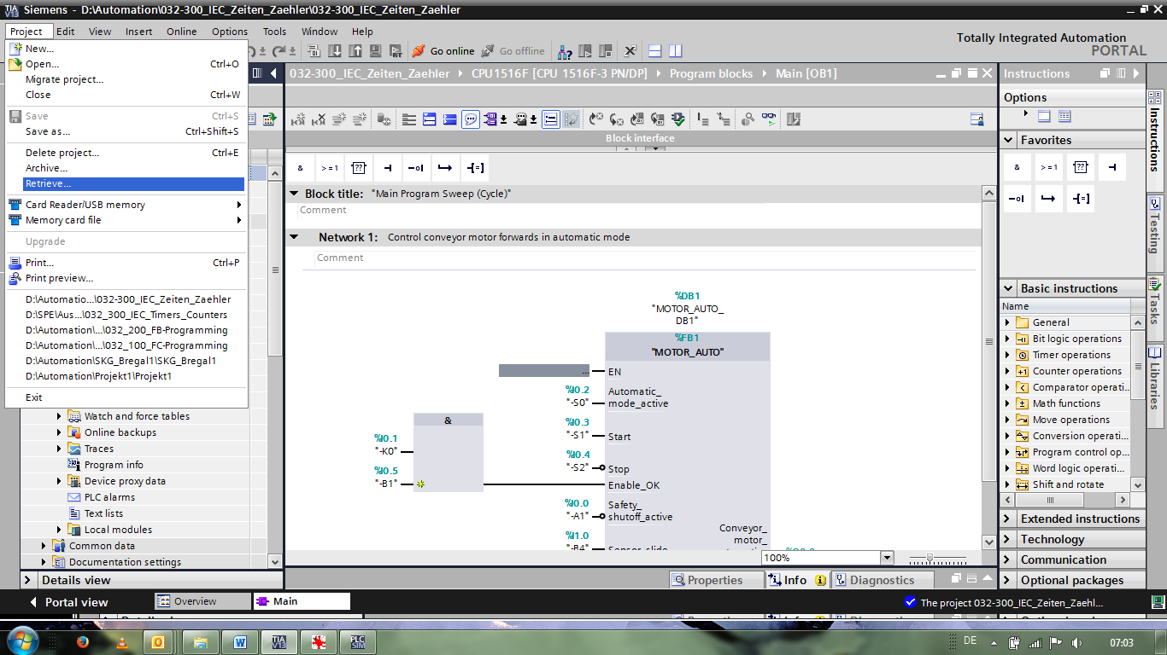

# Checklist

|  |  |  |
| --- | --- | --- |
| No. | Description | Completed |
| 1 | Compiling successful and without error message |  |
| 2 | Download successful and without error message |  |
| 3 | Switch on station (-K0 = 1)  Cylinder retracted / Feedback activated (-B1 = 1)  EMERGENCY OFF (-A1 = 1) not activated  AUTOMATIC mode (-S0 = 1)  Pushbutton automatic stop not actuated (-S2 = 1)  Briefly press the automatic start pushbutton (-S1 = 1)  Sensor at chute activated (-B4 = 1) then conveyor motor forwards fixed speed (-Q1 = 1) switches on and stays on. |  |
| 4 | Sensor at end of conveyor activated (-B7 = 1) → -Q1 = 0  (after 2 seconds) |  |
| 5 | Briefly press the automatic stop pushbutton (-S2 = 0) → -Q1 = 0 |  |
| 6 | Activate EMERGENCY OFF (-A1 = 0) → -Q1 = 0 |  |
| 7 | Manual mode (-S0 = 0) → -Q1 = 0 |  |
| 8 | Switch off station (-K0 = 0) → -Q1 = 0 |  |
| 9 | Cylinder not retracted (-B1 = 0) → -Q1 = 0 |  |
| 10 | Project successfully archived |  |

# Exercise

## Task – Exercise

In this exercise, an IEC counter is also to be added to the MOTOR\_AUTO [FB1] function block. The expanded function block will be planned, programmed and tested:

The magazine for plastic holds only 5 parts and the parts will therefore be counted at the end of the conveyor.

When 5 parts are stored in the magazine, automatic mode is to be stopped.

Once the magazine has been emptied, automatic mode will be restarted with

Start\_command is started again and the counter is reset.

## Planning

Plan the implementation of the task on your own.

**Note:** Learn about the use of IEC counters in SIMATIC S7-1500 in the online help.

## Checklist – Exercise

|  |  |  |
| --- | --- | --- |
| **No.** | **Description** | **Completed** |
| 1 | Compiling successful and without error message |  |
| 2 | Download successful and without error message |  |
| 3 | Switch on station (-K0 = 1)  Cylinder retracted / Feedback activated (-B1 = 1)  EMERGENCY OFF (-A1 = 1) not activated  AUTOMATIC mode (-S0 = 1)  Pushbutton automatic stop not actuated (-S2 = 1)  Briefly press the automatic start pushbutton (S1 = 1)  Sensor at chute activated (-B4 = 1)  then conveyor motor forwards fixed speed (-Q1 = 1) switches on and stays on. |  |
| 4 | Sensor at end of conveyor activated (-B7 = 1) → -Q1 = 0  (after 2 seconds) |  |
| 5 | Briefly press the automatic stop pushbutton (-S2 = 0) → -Q1 = 0 |  |
| 6 | Activate EMERGENCY OFF (-A1 = 0) → -Q1 = 0 |  |
| 7 | Manual mode (-S0 = 0) → -Q1 = 0 |  |
| 8 | Switch off station (-K0 = 0) → -Q1 = 0 |  |
| 9 | Cylinder not retracted (-B1 = 0) → -Q1 = 0 |  |
| 10 | 5th part in magazine → -Q1 = 0 |  |
| 11 | Project successfully archived |  |

# Additional information

You can find additional information as an orientation aid for initial and advanced training, for example: Getting Started, videos, tutorials, apps, manuals, programming guidelines and trial software/firmware, at the following link:  
  
[www.siemens.com/sce/s7-1500](http://www.siemens.com/sce/s7-1500)